FlightReservation

- Flight Entity (ជើងហោះហើយ)
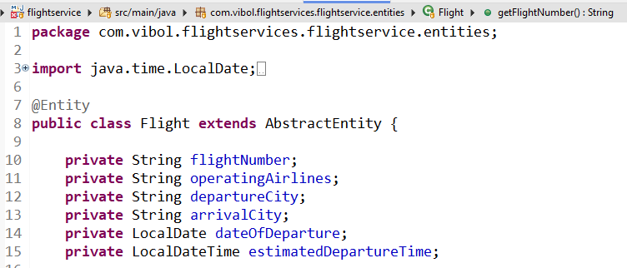

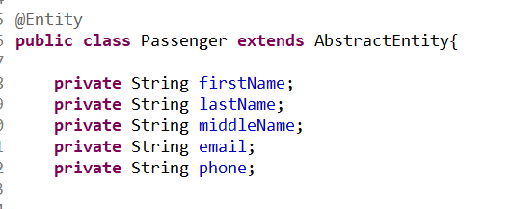
- Passenger អ្នកដំណើរ

- Reservation ការកកសំបុត្រ
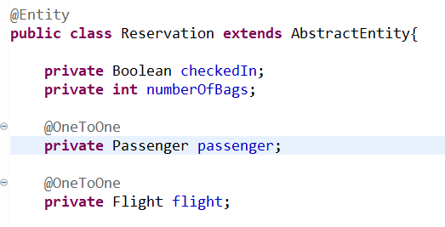

- AbstracEntity
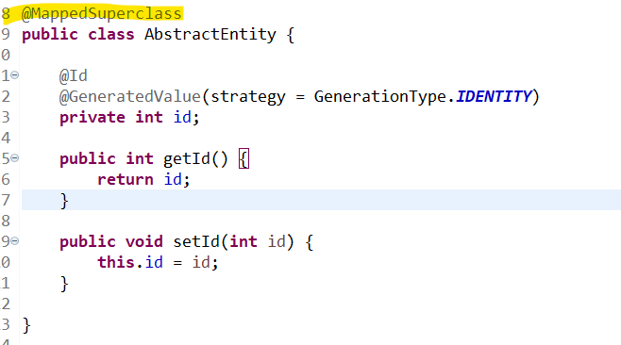

យើងអោយ Class ផ្សេងដែលមានទិន្នន័យដូចគ្នាស្ទួនអាចប្រើប្រាស់បាន
II. Create controller
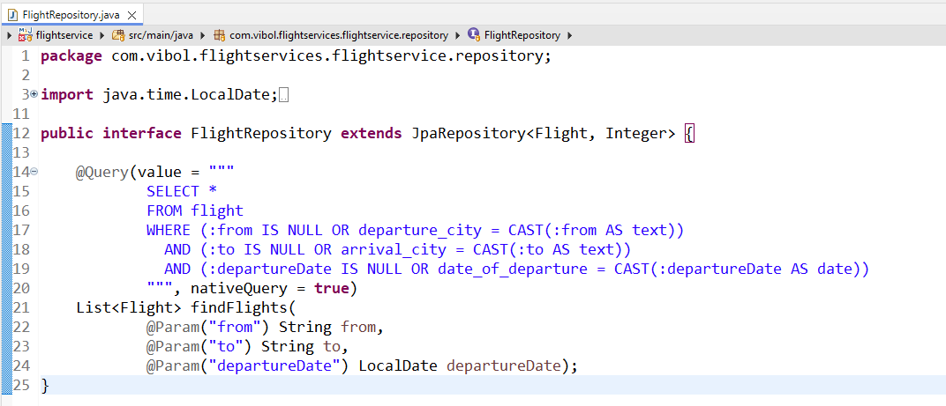

Custom query for search:
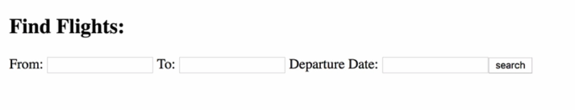

package com.vibol.flightservices.flightservice.repository;

import java.time.LocalDate;
import java.util.List;

import org.springframework.data.jpa.repository.JpaRepository;
import org.springframework.data.jpa.repository.Query;
import org.springframework.data.repository.query.Param;

import com.vibol.flightservices.flightservice.entities.Flight;

public interface FlightRepository extends JpaRepository<Flight, Integer> {

@Query(value = """
SELECT *
FROM flight
WHERE (:from IS NULL OR departure_city = CAST(:from AS text))
AND (:to IS NULL OR arrival_city = CAST(:to AS text))
AND (:departureDate IS NULL OR date_of_departure = CAST(:departureDate AS date))
""", nativeQuery = true)
List<Flight> findFlights(
@Param("from") String from,
@Param("to") String to,
@Param("departureDate") LocalDate departureDate);
}

- PassengerRepository
- ReservationRepository
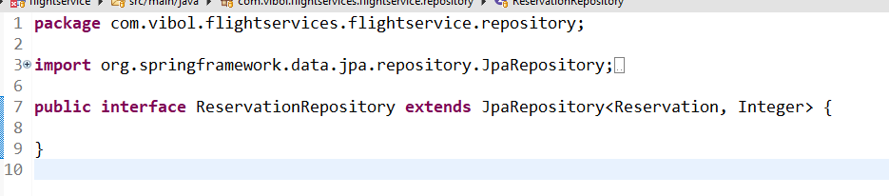

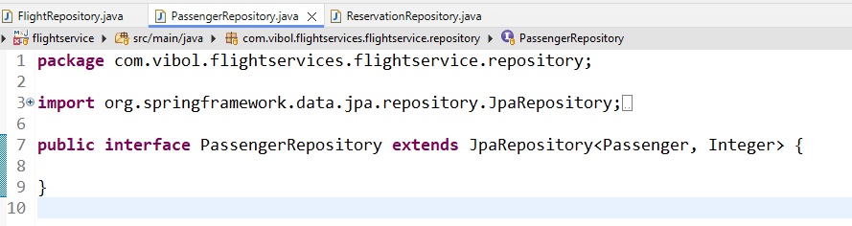

API:

package com.vibol.flightservices.integration;

import java.time.LocalDate;
import java.util.List;

import org.springframework.beans.factory.annotation.Autowired;
import org.springframework.format.annotation.DateTimeFormat;
import org.springframework.http.ResponseEntity;
import org.springframework.web.bind.annotation.CrossOrigin;
import org.springframework.web.bind.annotation.DeleteMapping;
import org.springframework.web.bind.annotation.GetMapping;
import org.springframework.web.bind.annotation.PathVariable;
import org.springframework.web.bind.annotation.PostMapping;
import org.springframework.web.bind.annotation.PutMapping;
import org.springframework.web.bind.annotation.RequestBody;
import org.springframework.web.bind.annotation.RequestMapping;
import org.springframework.web.bind.annotation.RequestParam;
import org.springframework.web.bind.annotation.RestController;

import com.vibol.flightservices.dto.CreateReservationRequest;
import com.vibol.flightservices.dto.UpdateReservationRequest;
import com.vibol.flightservices.flightservice.entities.Flight;
import com.vibol.flightservices.flightservice.entities.Passenger;
import com.vibol.flightservices.flightservice.entities.Reservation;
import com.vibol.flightservices.flightservice.repository.FlightRepository;
import com.vibol.flightservices.flightservice.repository.PassengerRepository;
import com.vibol.flightservices.flightservice.repository.ReservationRepository;

import jakarta.transaction.Transactional;

@RestController
@CrossOrigin(origins = "*")
@RequestMapping("/reservations")
public class ReservationRestController {

@Autowired
FlightRepository flightRepository;

@Autowired
PassengerRepository passengerRepository;

@Autowired
ReservationRepository reservationRepository;

// --- CREATE ---
@PostMapping
@Transactional
public Reservation saveReservation(@RequestBody CreateReservationRequest request) {
Flight flight = flightRepository.findById(request.getFlightId())
.orElseThrow(() -> new RuntimeException("Flight not found"));

Passenger passenger = new Passenger();
passenger.setFirstName(request.getPassengerFirstName());
passenger.setLastName(request.getPassengerLastName());
passenger.setMiddleName(request.getPassengerMiddleName());
passenger.setEmail(request.getPassengerEmail());
passenger.setPhone(request.getPassengerPhone());

Passenger savedPassenger = passengerRepository.save(passenger);

Reservation reservation = new Reservation();
reservation.setFlight(flight);
reservation.setPassenger(savedPassenger);
reservation.setCheckedIn(false);
reservation.setNumberOfBags(1);

return reservationRepository.save(reservation);
}

// --- READ ALL ---
@GetMapping
public List<Reservation> findAllReservations() {
return reservationRepository.findAll();
}

// --- READ BY ID ---
@GetMapping("/{id}")
public ResponseEntity<Reservation> findReservation(@PathVariable int id) {
return reservationRepository.findById(id)
.map(ResponseEntity::ok)
.orElse(ResponseEntity.notFound().build());
}

// --- UPDATE ---
@PutMapping("/{id}")
public ResponseEntity<Reservation> updateReservation(@PathVariable int id, @RequestBody UpdateReservationRequest request) {
return reservationRepository.findById(id)
.map(reservation -> {
reservation.setNumberOfBags(request.getNumberOfBags());
reservation.setCheckedIn(request.isCheckIn());
Reservation updated = reservationRepository.save(reservation);
return ResponseEntity.ok(updated);
})
.orElse(ResponseEntity.notFound().build());
}

// --- DELETE ---
@DeleteMapping("/{id}")
public ResponseEntity<Void> deleteReservation(@PathVariable int id) {
return reservationRepository.findById(id)
.map(reservation -> {
reservationRepository.delete(reservation);
return ResponseEntity.noContent().<Void>build();
})
.orElse(ResponseEntity.notFound().build());
}

// --- OTHER ENDPOINTS (FLIGHTS) ---
@GetMapping("/flights")
public List<Flight> findFlights(
@RequestParam(required = false) String from,
@RequestParam(required = false) String to,
@RequestParam(required = false)
@DateTimeFormat(pattern = "MM-dd-yyyy") LocalDate departureDate) {

return flightRepository.findFlights(from, to, departureDate);
}

@PostMapping("/addflight")
public String addFlight(@RequestBody Flight flight) {
flightRepository.save(flight);
return "Add Flight Successful";
}

}

JSON:

- Add flight
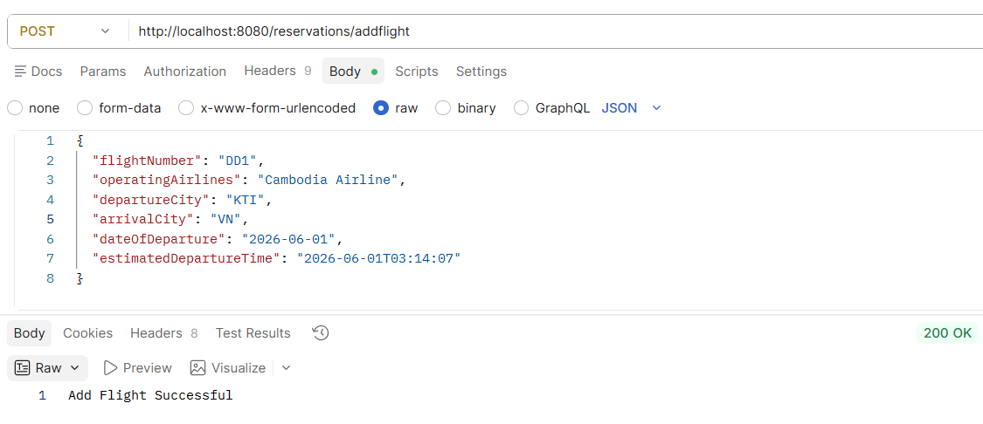

{
"flightNumber": "DD1",
"operatingAirlines": "Cambodia Airline",
"departureCity": "KTI",
"arrivalCity": "VN",
"dateOfDeparture": "2026-06-01",
"estimatedDepartureTime": "2026-06-01T03:14:07"
}

Swagger UI:

http://localhost:8080/swagger-ui.html

